Running Without Pain
A FREE workshop with Jon Deming, DPM of True 2 Form Biomechanics in conjunction with The Dome Sports Center
80% of all runners
will suffer from an injury. How can YOU avoid this statistic?
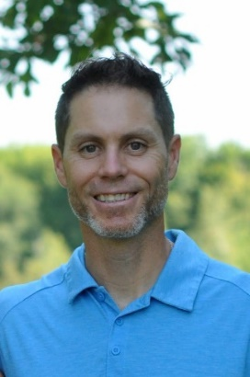
Jonathan Deming is a board-certified podiatric surgeon with over 10 years of experience in specialized foot and ankle care. Now the owner of True 2 Form Biomechanics & Sports Medicine, Dr. Deming focuses on evaluating athletes, especially runners, and helping them perfect their form to not only become faster and stronger but also avoid injuries. For those who may already be suffering from pain or injury, True 2 Form offers unique options for care to keep you active, moving, avoiding long layoffs in training, invasive procedures or even surgery.

Inviting runners of all ages to join us at True 2 Form – part of the Dome Sports Science Center
Wed March 9th
6-7pm
12849 US-131; Suite 2
Schoolcraft, MI 49087 To attend virtually RSVP:
(269) 679-7777 jdeming@t2form.com

